ACTS 13-14

I. JERUSALEM (Acts 1:1 - 8:4)
II. JUDEA & SAMARIA (Acts 8:5 - 12:25)
III. THE END OF THE EARTH (Acts 13:1 - 28:31)
A. The First Evangelistic Trip (13-14)
1. Province - Syria: Antioch & Seleucia (13:1-4)
2. Province - Cyprus: Salamis & Paphos (13:5-12)
3. Province - Pamphylia: Perga (13:13)
4. Province - Galatia: Antioch of Pisidia (13:14-52)
Iconium of Lycaonia (14:1-5)
Lystra of Lycaonia (14:6-19)
Derbe of Lycaonia (14:20)
~RETURN~
Lystra of Lycaonia (14:21-23)
Iconium of Lycaonia
Antioch of Pisidia
5. Province - Pamphylia: Perga (14:24-25)
Attalia (14:25)
6. Province - Syria: Antioch (14:26-28)

NOTE 1: In chapters 1-12, the church is established in Jerusalem, Samaria, Judea and the borders thereof. In chapters 12-28, we see it spread to "the uttermost parts" of the earth. Also, in chapters 1-12, various people are highlighted (Stephen, Philip, Cornelius, etc.) and the apostle Peter is emphasized. Then in Acts 12-28, fewer people are highlighted while Paul is emphasized. One reason Peter & Paul are emphasized is to give support for the apostleship of Paul:

PETER'S LIFE PAUL'S LIFE
1. Heal lame (3:1-10) 1. Heal lame (14:8-10)
2. Persecution by Jews (4:1-22; 5:17f 2. Persecution by Jews (13:44-45, 50-51)
3. Prison, free by miracle (5:19f; 12f) 3. Prison, free by miracle (16:19-30)
4. Extent of miracles: shadow (5:15f) 4. Extent of miracles: handkerchief (19:11-12)
5. Laying on of hands (Acts 8:14-18) 5. Laying on of hands (19:6)
6. Simon, the sorcerer (8:18-24) 6. Elymas, the sorcerer (13:6-12)
7. Tabitha raised form dead (9:36-43) 7. Eutychus raised from dead (20:9-12)
8. Peter refused worship (10:25-26) 8. Paul refused worship (14:14-15)

PETER'S TEACHINGS PAUL'S TEACHINGS
9. Sent by the H.S. to preach (10:19-20) 9. Sent by the H.S. to preach (13:2)
10. Boldness (4:31) 10. Boldness (9:28; 14:3)
11. Christ' death, burial, res. (2, 10) 11. Christ' death, burial, res. (13:28-30)
12. Live godly (2:40) 12. Live godly (14:22)
13. Forgiveness (2:38) 13. Forgiveness (13:38)
14. Gentiles (2:39; 10:34-35) 14. Gentiles (13:46-48)

NOTE 2: Saul's first journey lasted approximately four years (~45-49 AD). It also covered a distance of some 1200-1300 miles. His list of companions included Barnabas, John Mark, and others not specified. It is on this trip that Paul converts people in the region of Lycaonia, which includes the cities of Derbe, Lystria & Iconium. Later, Paul will return here and find a disciple well reported of and useful to him, named Timothy (Acts 16:1-4).

QUESTIONS FOR ACTS 13:1-12 Province - Syria: Antioch & Seleucia
Province - Cyprus: Salamis & Paphos

1. What is the topic / event that is covered in Acts 13-14?

2. What "gifts" were in the church at Antioch (13:1; Eph. 4:8, 11)?

3. What was Simeon's surname / nickname (13:1)? What did this name mean? What can be learned from this?

4. Indentify Lucius (Acts 13:1; 11:19-20; Rom. 16:21). What can we learn here?

5. Manaen (13:1) was the son of the woman who nursed Herod Antipas. What can be learned from this?

6. What were these men doing (13:2)? What did the Spirit say to them?

7. What can we learn about the Spirit here (13:2)?

8. Who was to do the "separating" & "sending" unto this work (13:1-3)? Was it a missionary society?

9. What did they do before sending them away (13:3)? Why?

10. Why did Saul & Barnabas receive the "laying on of hands" (13:3)? Did this make them both apostles?

11. Does the NT require Christians to fast (13:3)? Explain.

12. When the church obeys the word & sends forth men to preach, who has really sent them (13:2)? (cp Acts 20:28)

13. Where did they go (13:4-6)? Mark your map (next page).

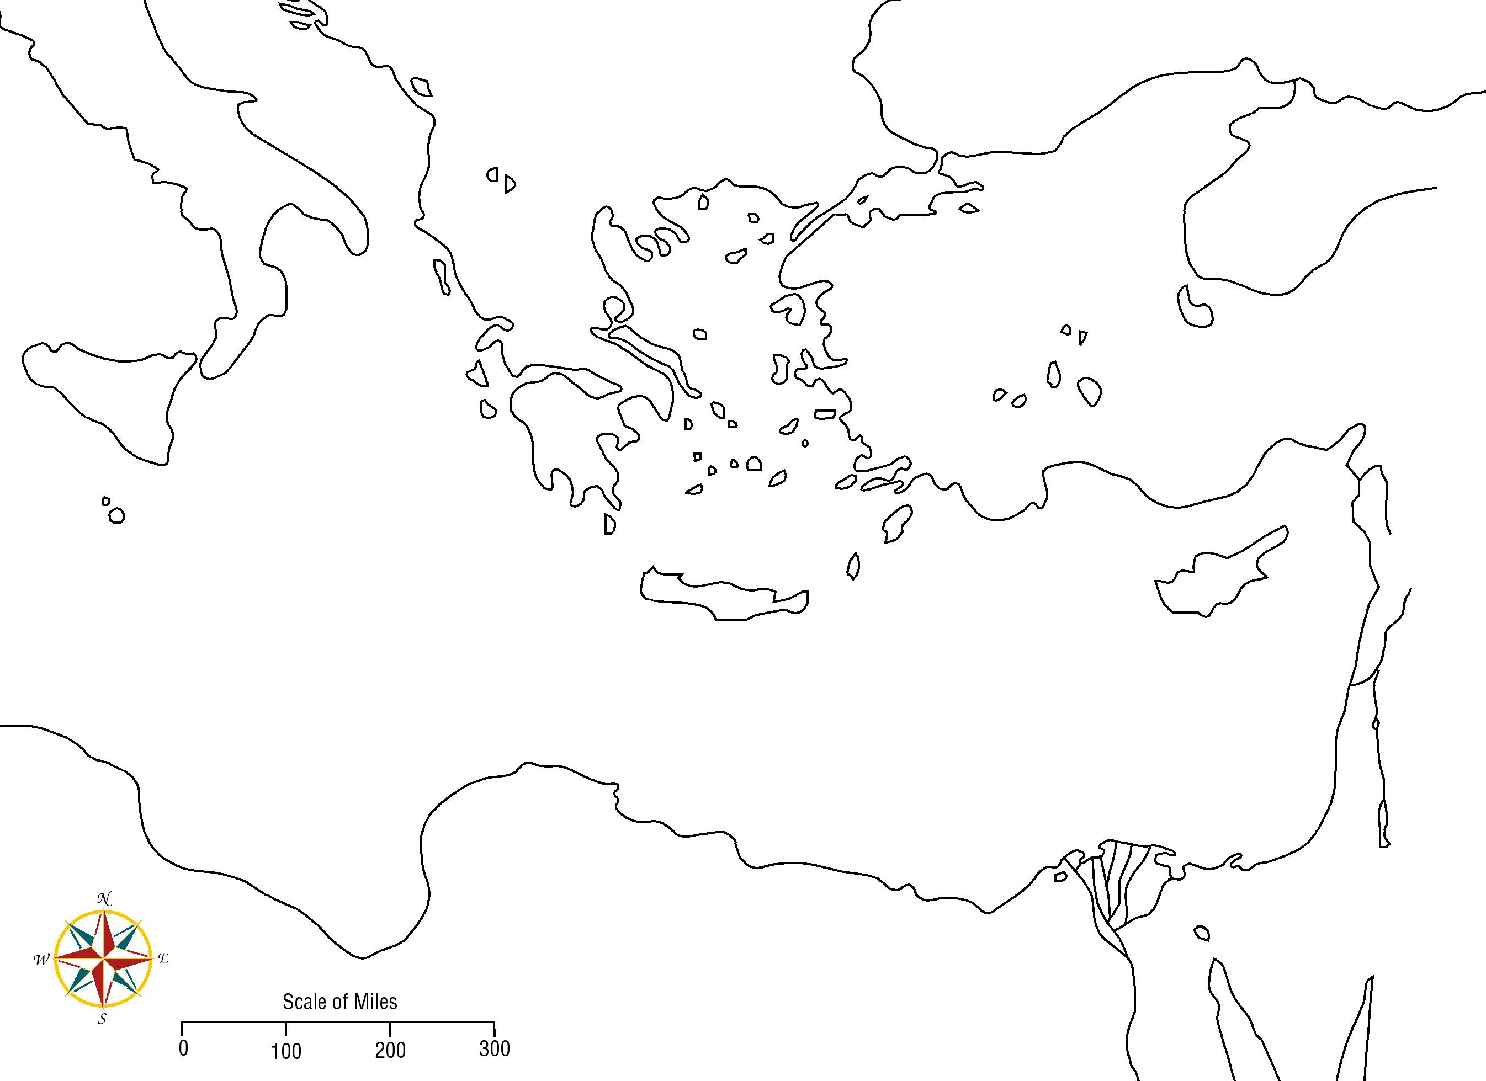
14. Who is from this province (Acts 4:36)?

15. Where did they first speak while there (13:5)?

16. Who was also with them (13:5)? What purpose did he serve?

17. Who did they encounter at Paphos (13:6)?

18. Who was the proconsul (13:7)? What was a proconsul?

19. How is the proconsul described (13:7)?

20. What did Elymas do (13:8)? Why?
21. (T) (F) All prophets are true prophets.

22. What is "the faith" equated to (13:5, 7, 8)?

23. Why might Saul's name be changed here (13:9)? Also, why might the order of names be changed beginning here (13:2, 13, 43)?

24. What does it mean that Paul was "filled with the Holy Spirit" (13:9)?

25. What was Paul's reaction to Elymas (13:9-11)? Why?

26. (T) (F) Paul sinned because he was not gentle.

27. (T) (F) Paul was a hot-head.

28. What reaction might these actions provoke in the person they are aimed at (13:9-10)?
A. Fastened eyes upon -

B. Directly tell a person of their sins -

C. Call a person the son of the devil -

D. Call a person an enemy of righteousness -

29. What do these mean?
A. Guile -

B. Villainy -

C. Son of the devil -

D. Enemy of righteousness -

E. Pervert the right ways of the Lord -

30. What exactly did Paul do to this false teacher (13:11)? Can modern miracle workers do this? If not, why not?

31. What was the proconsul's reaction (13:12)? Was he turned off by what Paul did?

32. What is the relationship between seeing the miracle & believing the teaching (13:12)?

33. Why might the teaching of the Lord be astonishing (13:12)?

QUESTIONS FOR ACTS 13:13 Province - Pamphylia: Perga
34. What city did they travel to now (13:13)? In what province? Mark you map.

35. Who departed to Jerusalem (13:13)? How might this affect those who remained (cp. 15:38)?

QUESTIONS FOR ACTS 13:14-43 Province - Galatia: Antioch of Pisidia
36. What city & province did they go to in 13:14? Mark you map.

37. Why did Paul & his company go to the synagogue on the Sabbath (13:14)? Could we do the same today?

38. What was read in the synagogue (13:15)?

39. What did the rulers of the synagogue ask of them (13:15)?

40. (T) (F) Paul came intending to preach.

41. (T) (F) Paul forced himself upon the synagogue & violated their autonomy.

42. What godly character trait did Paul bring to mind at the beginning of his lesson (13:16)?

43. What did the God of Israel do (13:17)?

44. How did God treat Israel for 40 years in the wilderness (13:18)? Why?

45. Who destroyed the seven nations that dwelt in Canaan (13:19)? Why?

NOTE: Acts 13:19 seems to say (ASV) that from the conquest until the time of the judges was "450 years"; but this would be impossible since 1 Kings 6:1 mentions that from the Exodus to the fourth year of Solomon's reign was 480 years. To better understand Acts 13:19, consider the NAS's rendering for Acts 13:17-20 (bold added for emphasis):

"17 The God of this people Israel chose our fathers and made the people great during their stay in the land of Egypt, and with an uplifted arm He led them out from it.
18 For a period of about forty years He put up with them in the wilderness.
19 When He had destroyed seven nations in the land of Canaan, He distributed their land
as an inheritance -all of which took about four hundred and fifty years.
20 After these things He gave them judges until Samuel the prophet."

Thus Paul was not stating the length of the conquest nor how long the judges had ruled; instead, the "about 450 years" modifies the time from when God "chose our fathers" (13:17) unto the distribution of the land (13:19).

46. What form of government did they have at this time (13:19-20)?

47. When did this change (13:20-21)? Why did this change? What point is (by implication) warned against in this example?

48. Who was Israel's first king (13:21)? For how long?

49. If Saul died in a battle against the Philistines, why does Paul say God "removed" him (13:22)?

50. Who was raised up next (13:22)? What did God say about his character & conduct?

51. How was King Saul different form David?

52. What happened through David's seed 'according to promise" (13:23)?

53. Who announced Jesus (13:24)? What did he teach?

54. What did John say about himself in comparison to Christ (13:25)? What does this show?

55. Why does Paul say the following... (13:26)?
A. Brethren -

B. Children of the stock of Abraham -

C. Those that fear God -

56. What does the statement "the word of this salvation" show about salvation (13:26)?

57. How did "they that dwell in Jerusalem & their rulers" fulfill the scriptures (13:27, 29)?

58. Why did they not know Christ (13:27)?
59. Explain what is meant by the "voices" of the prophets being read (13:27).

60. Is verse 28 just Peter's opinion or interpretation of events (13:28-29)?

61. Who raised Jesus from the dead (13:30; Rom. 8:11; John 10:18)?

62. Who saw Jesus for many days after He was raised (13:31)? What are they now because of this?

63. What promise was given to the Hebrew fathers that God fulfilled (13:32-33)? Where is this promise recorded?

64. Jehovah's Witnesses claim that Jesus is the "Son" of God because He was created. How does Acts 13:33 prove this to be false?

65. When was Jesus "begotten" (13:33)?
A. At His creation.
B. At His physical birth.
C. At His baptism.
D. At His resurrection.

66. What two passages does Paul refer to in order to show that Jesus was raised and will not return to corruption (13:34-35)?

67. How does Paul prove that these prophesies did not apply to David (13:36-37)?

68. How does Paul describe David's character & life (13:36)?

69. What contrast exists between Christ & the law of Moses (13:38-39)?

70. What statement is parallel to "remission of sins" (13:38-39)?

71. Who may receive the remission of sins (13:39)?

72. What warning did Paul give to the listeners (13:40-41)? Was Paul just being negative in his preaching?

73. Where is Acts 13:41 a reference from?

74. What was the initial reaction of the listeners (13:42-43)?

75. Calvinism teaches that God sovereignly applies grace and there is nothing the elect can do about it. What does Acts 13:43 say that refutes this error?

76. (T) (F) Paul only used one scripture in his lesson, because the average listener can not understand more than one at a time.

QUESTIONS FOR ACTS 13:44-52 Province - Galatia: Antioch of Pisidia
77. On the next sabbath, who gathered to hear the word of God (13:44)?

78. What is the connection between the grace of God (13:43) and the word of God (13:44)?

79. What was the response of the Jews when they saw the multitudes (13:45)? How does this passage help us to understand why people do not understand the Bible alike?

80. (T) (F) Faithful preachers will be loved by everyone.

81. What does the word blasphemy mean (13:45)?

82. When people contradicted the truth, in what manner did Paul & Barnabas respond (13:46)?

83. Why was it necessary to speak the word of God at the synagogue first (13:46a)?

84. When the Jews responded this way, how did Paul & Barnabas describe their conduct (13:46b)? Is it possible to commit this same error today?

85. What scripture did Paul & Barnabas use to prove that the Gentiles could hear the gospel (13:47)?

86. How does verse 47 accord with the theme of Acts?

87. In what way did the Gentiles glorify the word of God (13:48)?

88. Some think that verse 48 teaches unconditional election or Calvinistic predestination. Use the following details from the context to explain why Calvinism is not supported here. Also explain what is taught by these being ordained unto eternal life.

Those Who Judged Themselves  Unworthy of Eternal Life (13:46) | Those Ordained To Eternal Life (13:48)
v. 41 Despised & disbelieved God's word v. 45 Filled with envy  v. 45 Contradicted & blasphemed  v. 46 Thrust the word from themselves | v. 48 Were glad to hear  v. 48 Glorified the word  v. 48 Believed

89. What does Acts 13:49 necessarily imply?

90. What further mischief did the Jews stir up (13:50)? What resulted?

91. Seeing this many people from multiple cities upset at Paul & Barnabas, what might it be easy to conclude (13:51; cp. Prov. 18:17)?

92. What did Paul & Barnabas do "against" their persecutors (13:51)? Why?

93. Where did they go to next (13:51)? Mark your map (page 3).

94. What discouragements & obstacles did Paul & Barnabas face in their preaching (Acts 13)?

95. Even though there was persecution, what were the disciples filled with (13:52)? How is this possible?

96. Note the distinction between the emotions of the disciples and the activity of the Holy Spirit (13:52, 48). How does this passage help us to answer the Pentecostal/Charismatic errors?

QUESTIONS FOR ACTS 14:1-5 Province - Galatia: Iconium of Lycaonia
97. Where did they go to while in Iconium (14:1)? Why?

98. What was the result of preaching the word there (14:1)?

99. Does "and so spake" mean that Paul & Barnabas used a more eloquent & acceptable approach to impress & converting people (14:1)? Explain.
100. What did the disobedient Jews do (14:2)? Why does the term "poisoning the well" fit what took place here?

101. Does persecution mean that no one is interested? Does it mean we should back off on preaching the truth boldly.

102. How did Paul & Barnabas teach the word (14:3a)?

103. What did the Lord bear witness to (14:3)? How?

104. Why is "the word" connected with "his grace" (14:3)?

105. (T) (F) Teaching truth causes division (14:4). Explain.

106. (T) (F) Teaching truth brings unity (14:4). Explain.

107. After a long time (14:3), what did the disobedient of the city try to do (14:5)?

108. When they discovered the plot, where did they flee to (14:6)? Mark your map.

109. What did persecution result in (14:7)?

QUESTIONS FOR ACTS 14:6-20 Province - Galatia: Lystra & Derbe of Lycaonia
110. At Lystra, how long had the man been impotent in his feet (14:8)? Why is this important?

111. Does 14:9 teach that miracles will only be worked when the person to be healed has faith? Explain.

112. How long did it take for this miracle to be accomplished (14:10)?

113. How did the multitude react to what Paul did (14:11)? In what language did they say this?

114. What did they call Barnabas & Paul (14:12)? Why?

115. What does this incident show about preconceived ideas?

116. What did the priest of Jupiter bring & plan (14:13)?

117. When Barnabas & Paul understood what was happening, what did they do & why (14:14)?

118. What is the first reason Paul & Barnabas give for refusing to be worshipped (14:15a)?

119. How did they describe idolatry (14:15)?

120. How do they describe God (14:15)?

121. What two things necessarily imply the existence of God (14:15, 17)? Explain.

122. What did God allow in the past (14:16)? Does this mean He approved of their behavior?

123. How carried away were the multitudes with this error (14:18)?

124. What does it show that the Jews came from Antioch to Iconium (a 4 day, 60 miles journey) to Lystra (another 2 days of 19 miles) to find Paul & Barnabas (14:19-20)? What did they do while there?

125. What can be learned from their supposition in verse 19?

126. What happened as the disciples stood around Paul (14:20)? Do we know if this was a miracle?

127. Where did he go from there (14:20b)?

128. Why would God allow Christians (and even apostles!) to suffer such things?

129. Consider how the multitudes at Lystra went from trying to worship Paul & Barnabas (14:18) to stoning them (14:19). What does this show about the praise & ridicule of men? How should we react to such praise & ridicule?

QUESTIONS FOR ACTS 14:21-23 Province - Galatia: Lystra & Iconium of Lycaonia, Antioch of Pisidia ~RETURN~
130. How did they "make disciples" in Derbe (14:21; Matt. 28:19)?

131. After preaching in Derbe, where did Paul & Barnabas go (14:21-22)? What does it show that Paul & Barnabas were willing to go here?

132. What did they do while there (14:22)? How? Why might this be needed?

133. What does Acts 14:22 say that refutes the "once saved always saved" error?

134. How was Paul & Barnabas' message especially clear under the circumstances (14:22)?

135. Strong identifies "tribulations" in Acts 14:22 as #2347 [Thlipsis], meaning pressure (literally or figuratively):--afflicted(-tion), anguish, burdened, persecution, tribulation, trouble. Knowing that there are many tribulations to pass through in order to enter the kingdom of God, what should we do?

136. If disciples are placed into the kingdom (church) when they are baptized (John 3:3, 5; Acts 2:47); why did Paul & Barnabas say that they & the disciples were yet to enter it (Acts 14:22)?

137. What did Paul & Barnabas do (14:23a)? What does this teach about the organization of the church?

138. Does Acts 14:23 contradict Titus 1:5? Explain.

NOTE: "Appointed" (Acts 14:23) is Strong's 5500 [cheirotoneo]. It is a comparative of 5495 and teino (to stretch); to be a hand-reacher or voter (by raising the hand), i.e. (generally) to select or appoint:--choose, ordain.

139. Why does the text say that Paul & Barnabas appointed (14:23) them when Acts 6 shows that brethren were to select men from among themselves according to revealed qualifications, and Acts 20:28 says that the Holy Spirit "made" the bishops? Also, Paul told Timothy (1 Tim. 5:22) & Titus (Titus 1:5) to appoint elders. So, how are elders appointed? What place does "laying hands on" have?

140. Is fasting required in the appointment of elders (14:23)? Explain.

141. How was it possible to have men qualified so soon (Acts 14:23)?

142. (T) (F) Paul & Barnabas were always negative & stirring up trouble (Acts 14:22-23).

143. How does Acts 14:23 help show the following are unscriptural?
a. A bishop over a diocese -

b. A sponsoring church -

c. One bishop over a church -

d. Elders under a single bishop -

e. Young elders -

f. A board of deacons over a church -

144. What Roman Province were the cities of Antioch, Iconium, Lystra & Derbe in? What letter did Paul write some 11 years later to these churches? Why?

145. What does the church at Jerusalem later say about the work of Paul & Barnabas here (Acts 15:26)?

QUESTIONS FOR ACTS 14:24-25 Province - Pamphylia: Perga & Attalia
146. Where did they go to now (14:24-25)? Mark your map.

147. "And when they had _________ the _______ in Perga, they went down to Attalia" (14:25).

148. Consider the statement that "they went down to Attalia" (14:25) and "from thence they sailed" (14:26). While the Bible is not a geography book, what can we learn from this?

QUESTIONS FOR ACTS 14:26-28 Province - Syria: Antioch
149. Which Antioch did they come to (14:26)?

150. From the context, what does it mean to "fulfill" the work (14:26)?

151. What did Paul & Barnabas do with the church here (14:27)? How did they describe it?

152. Approximately when did this first evangelistic effort begin & conclude (Acts 13:1-14:28)?

153. (T) (F) Paul & Barnabas did not stay long at Antioch, for fear of becoming "located preachers".

154. List the cities, in order, which Paul & Barnabas visited on their first evangelistic effort.

